**12th Street Elementary**



**Amberly Elementary**

**Directions From I-94**

Take the Oakland Drive Exit. Head south. Go straight through light at Milham. Turn right on Tattersall. At dead end, turn left, then right back onto Tattersall. Go to the second stop sign. Turn left onto Amberly. The school in on your left.

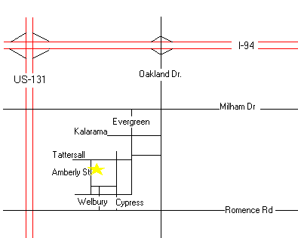

**Angling Road Elementary**



**Central Elementary**

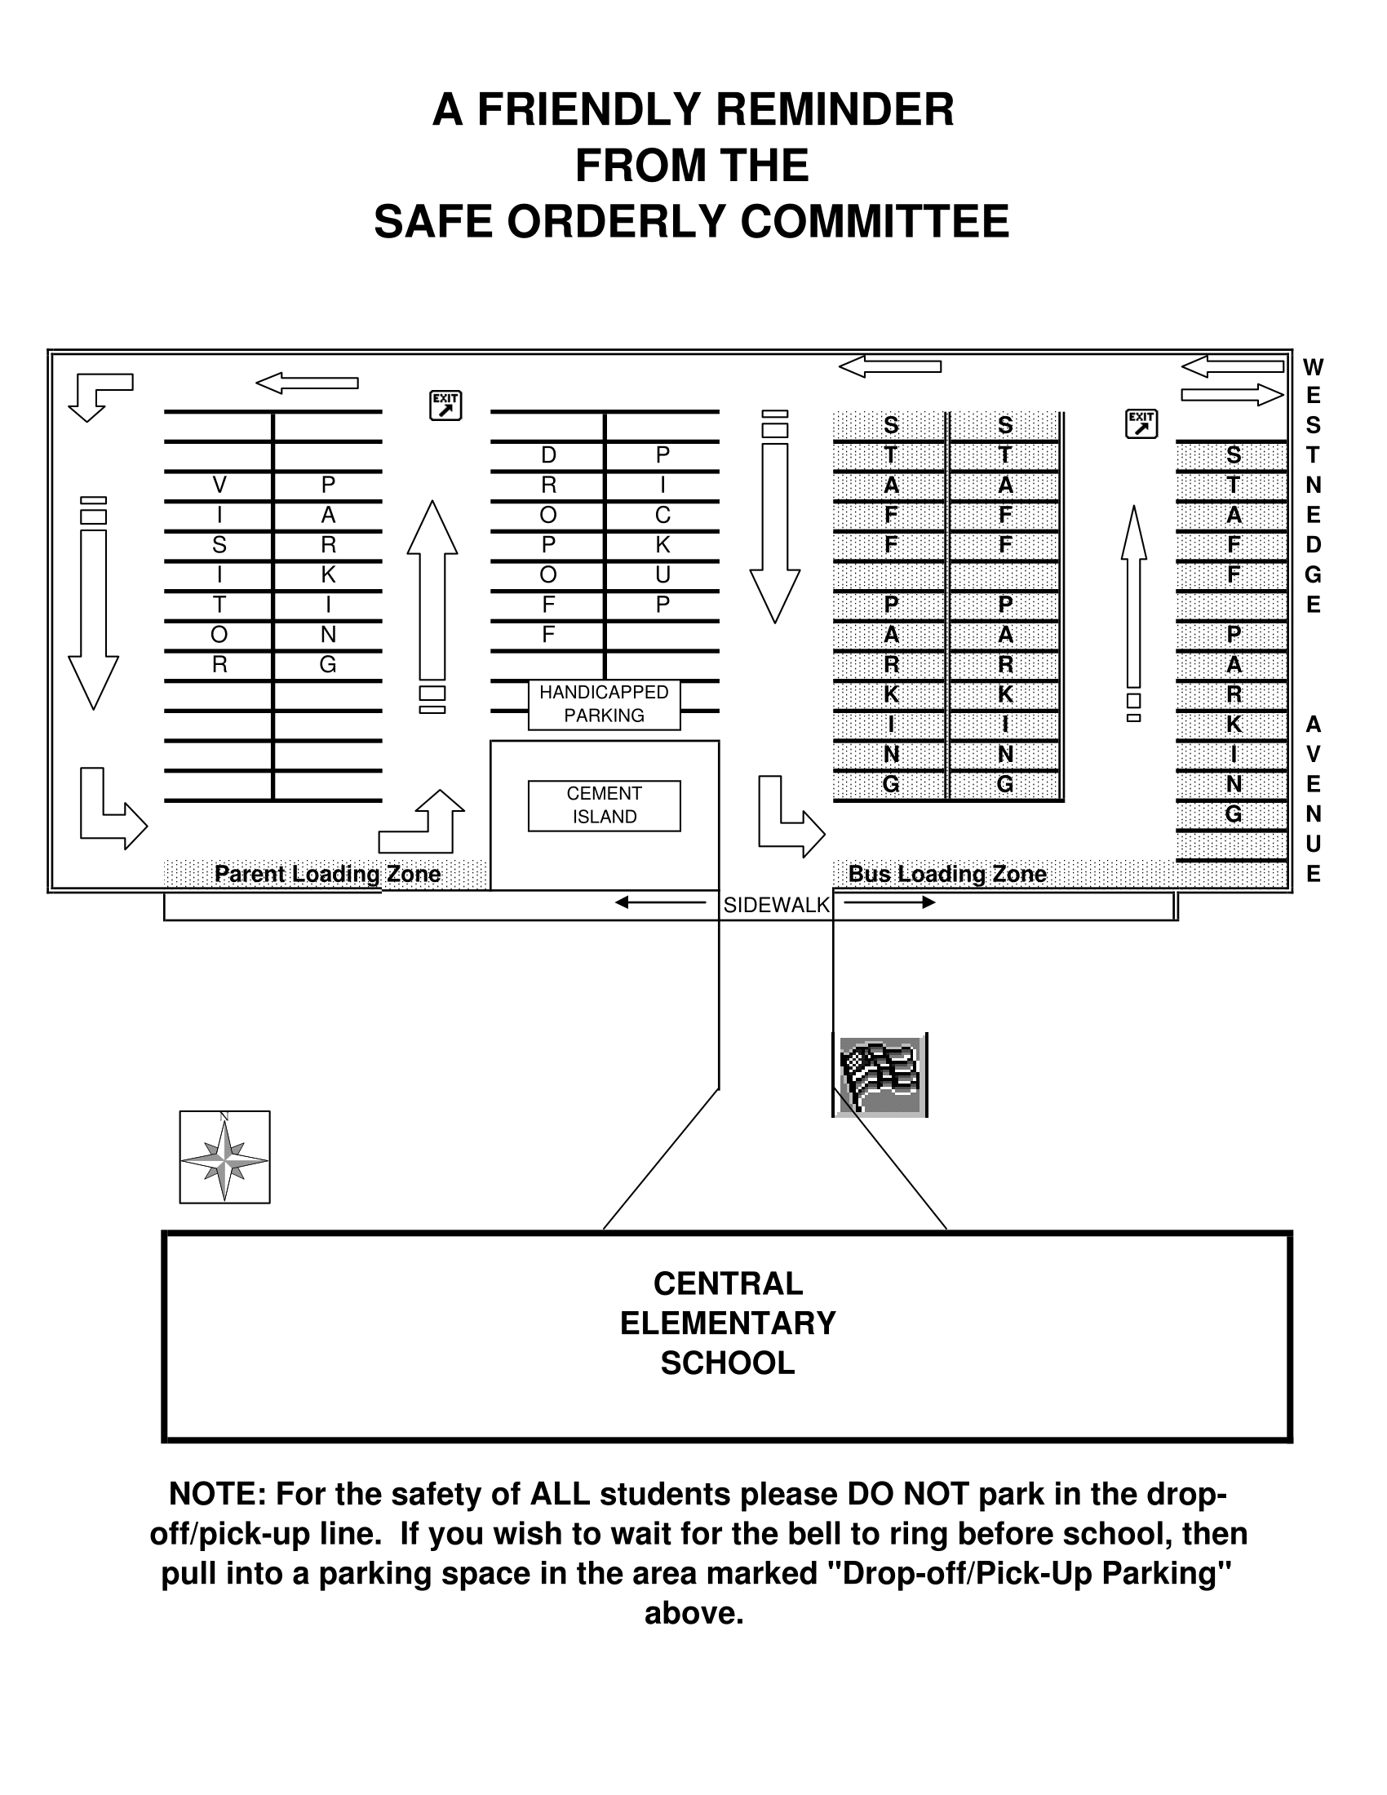

**Haverhill Elementary**



**Lake Center Elementary**



**Moorsbridge Elementary**

**Map to School**

Moorsbridge is located South of I-94 and East of US131. Exit from I-94 going south on Oakland Drive. Turn right on Romance Road and then take a left on Moorsbridge Road.

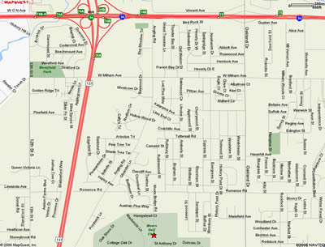

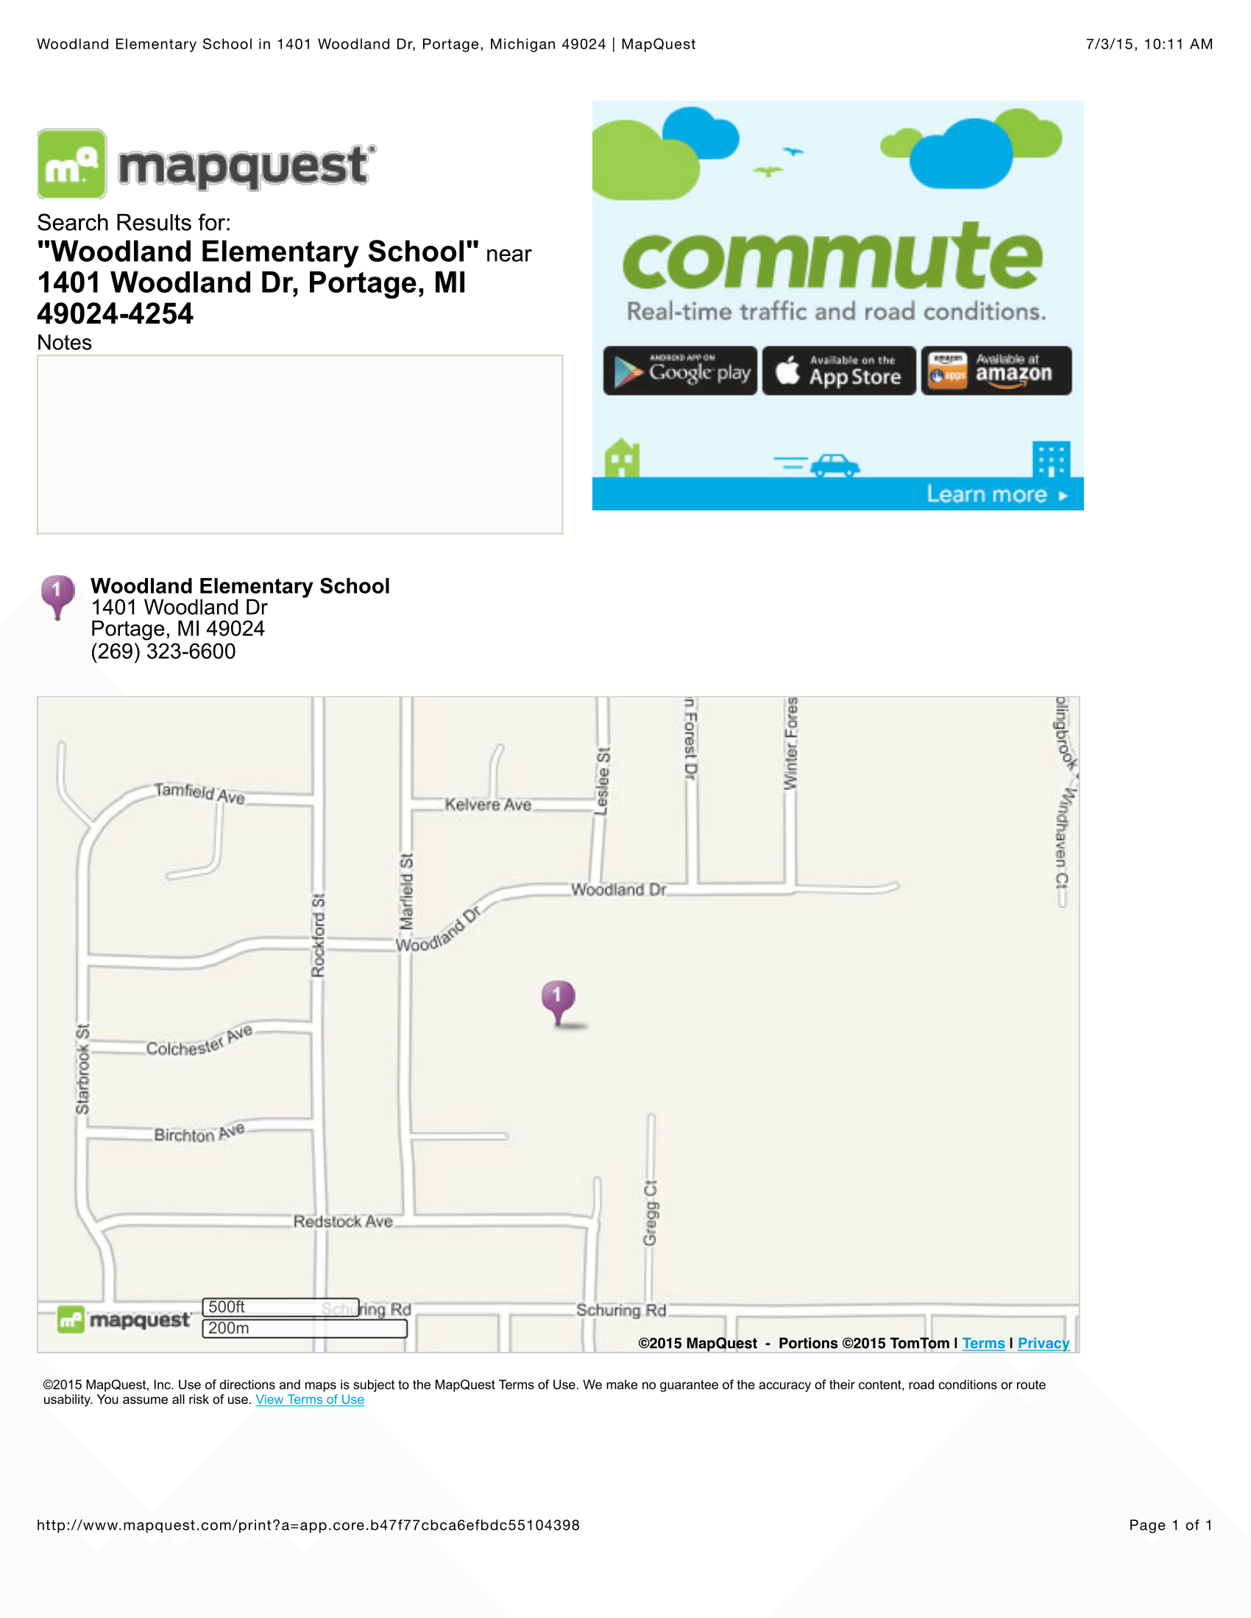

**Woodland Elementary**

**Central Middle**

**Traffic -** The turn-a-round in front of our building works very well “if” drivers do not park in this area. Thank you for helping us to have a safe flow of traffic in front of our building.

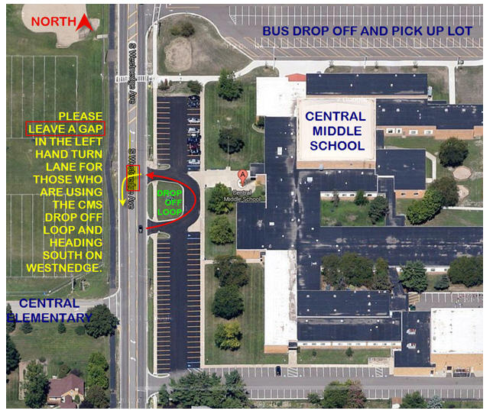

**North Middle**

**From East Or West**

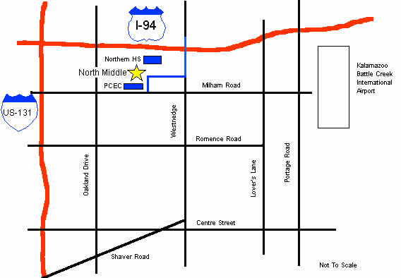

**NMS Parking Lot Traffic Guidelines**

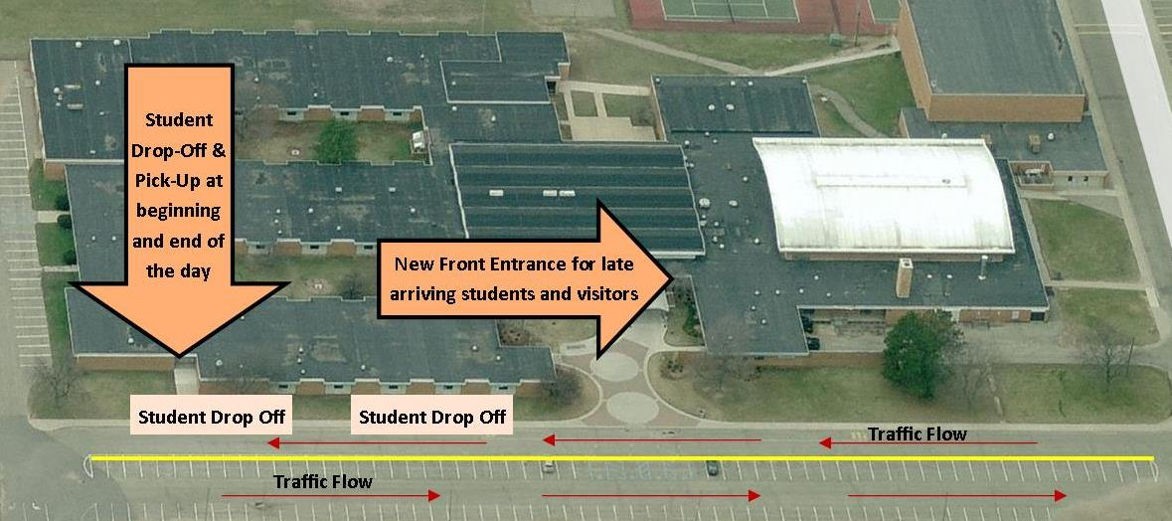

**West Middle**

**Directions**

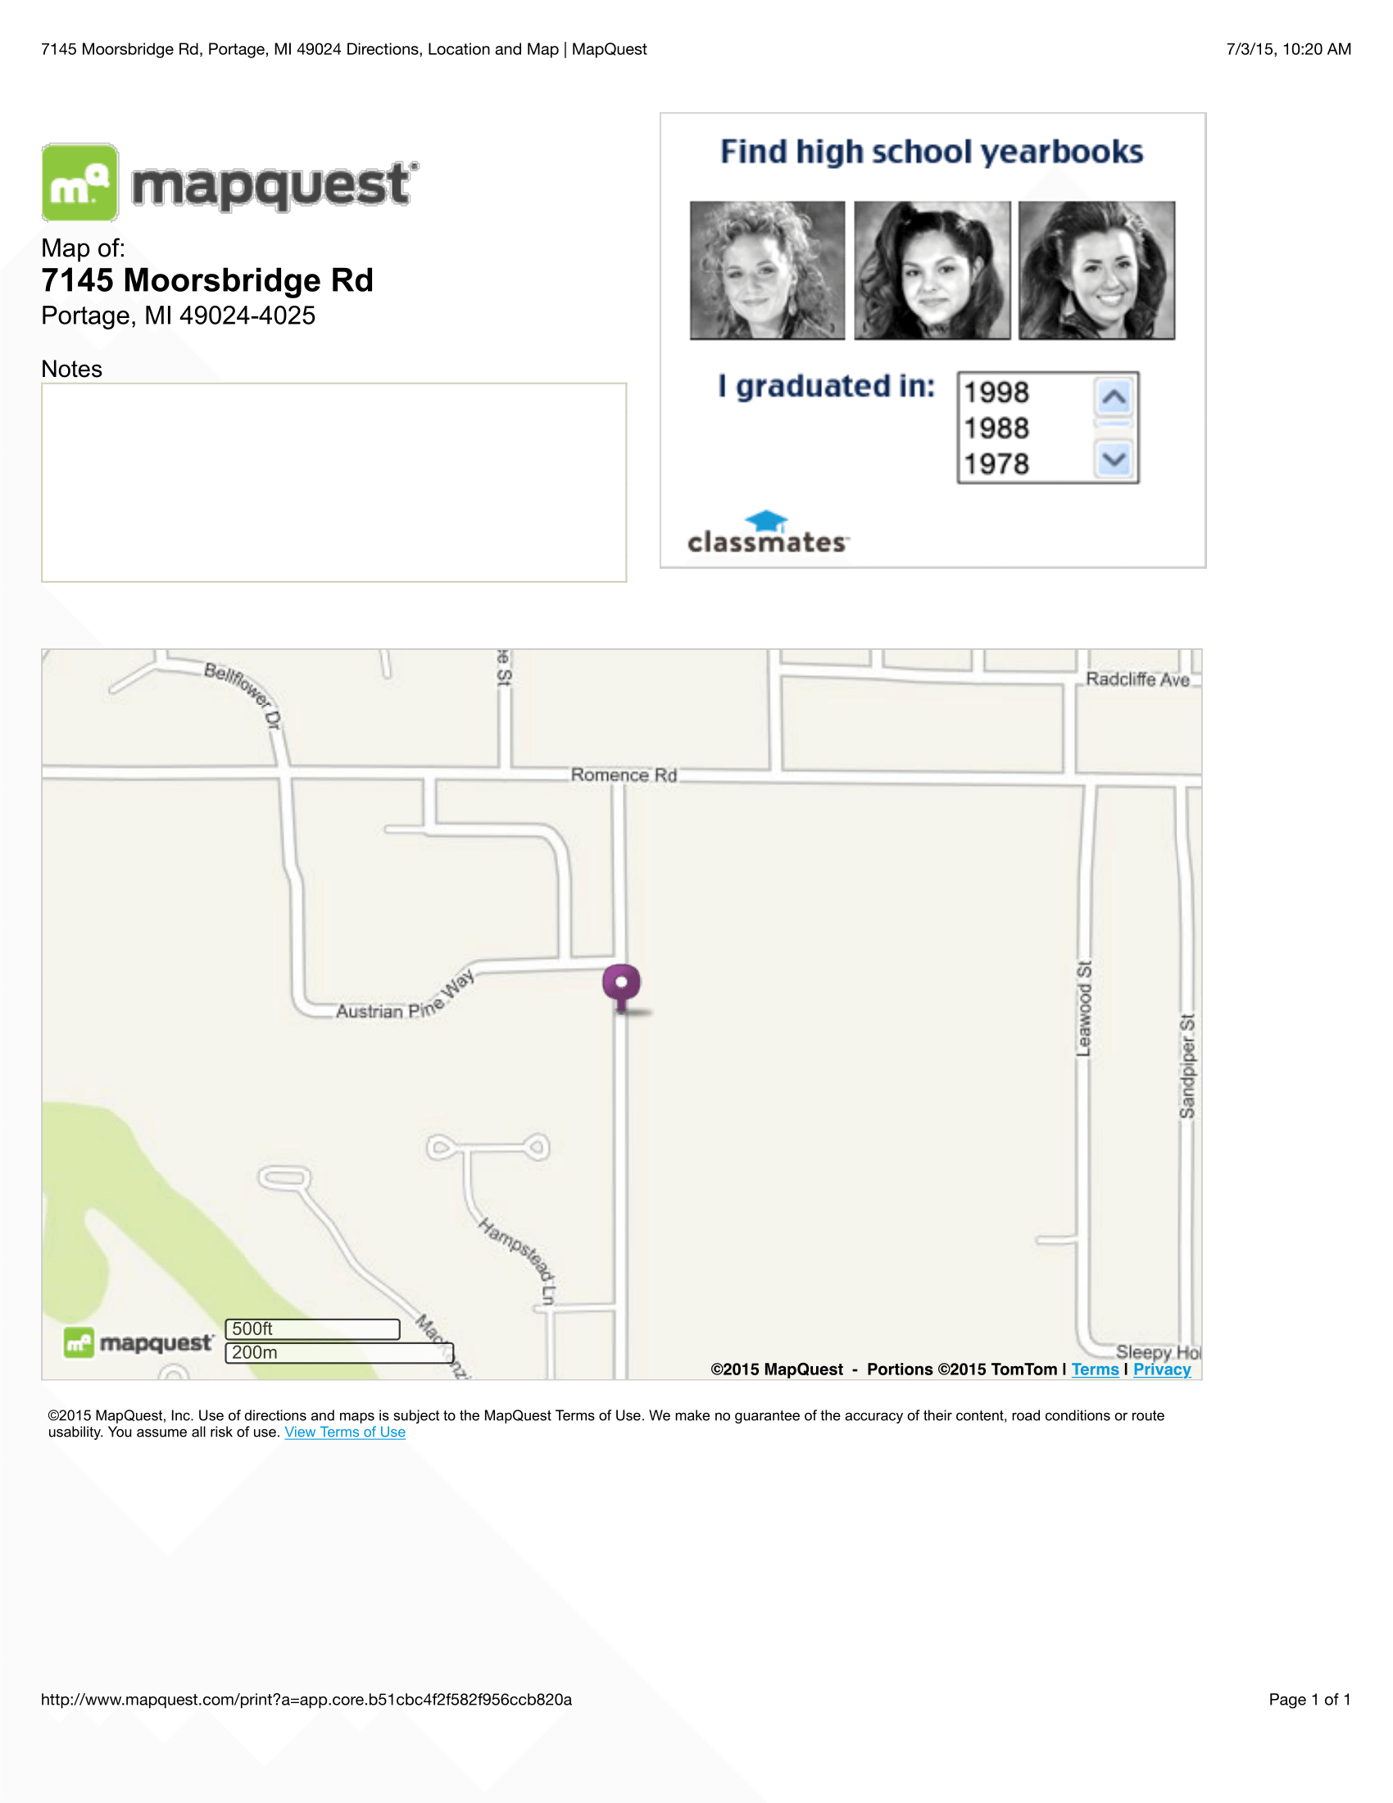

**Building Layout**

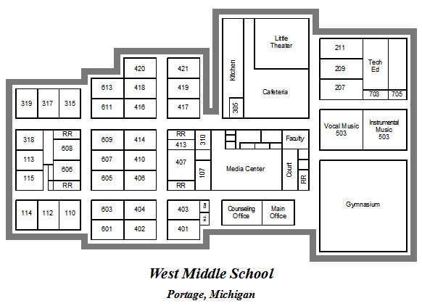

**Central High**

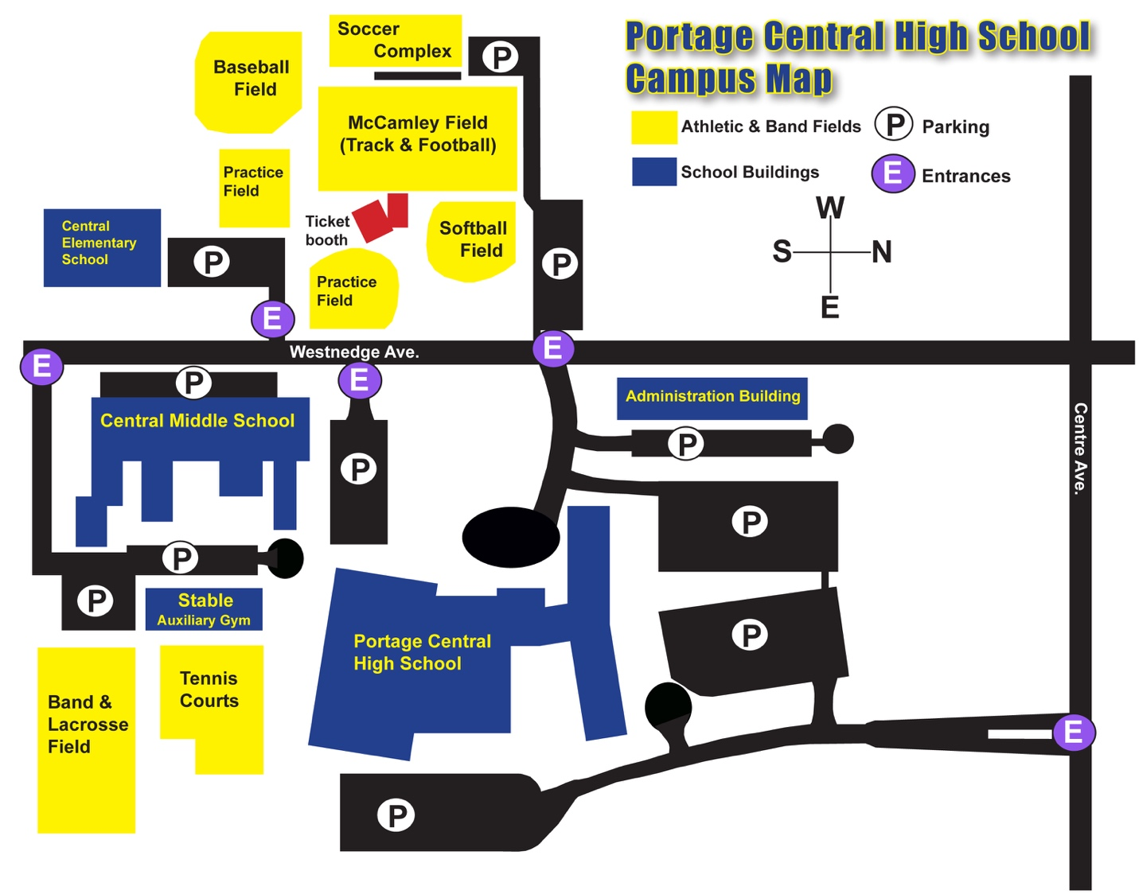

**Community High**



**Northern High**

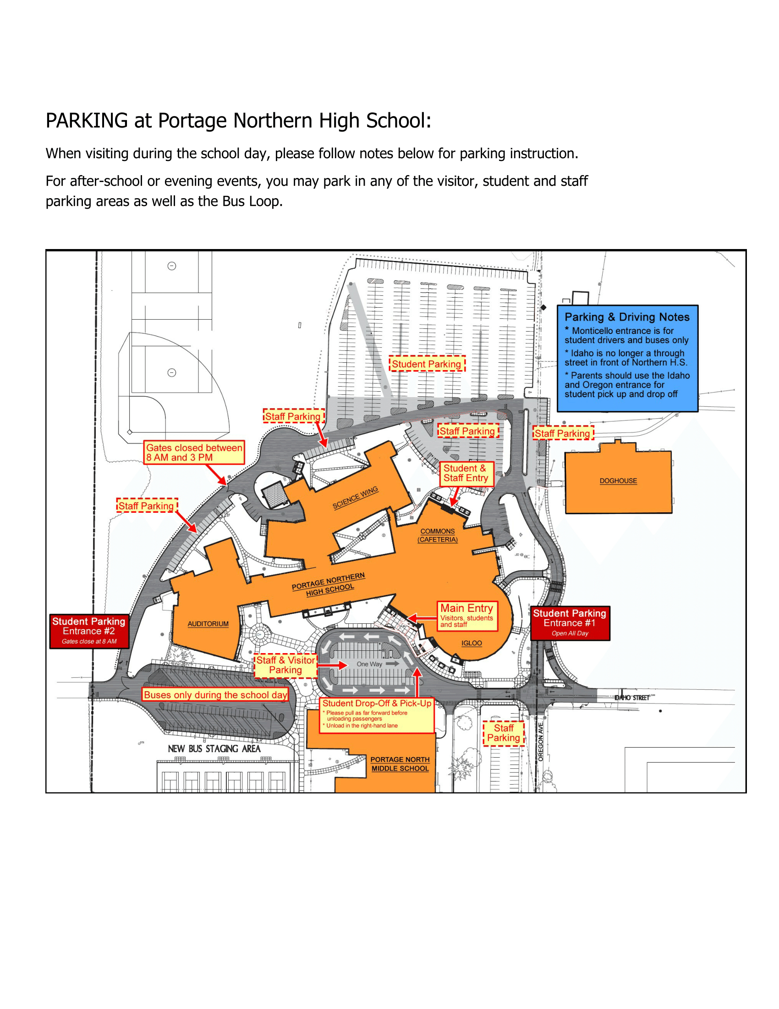

|  |
| --- |
| **PORTAGE PUBLIC SCHOOLS**  ***2015-2016 Student Calendar***  Elementary:  8:23 am (first bell is at 8:20) and dismisses at 3:38 pm; half day dismissal at 11:40 am.  Middle & High School:  7:35 am and dismisses at 2:50 pm; half day dismissal at 10:50 am.  September 8 - First day of School; morning only  October 12 - Half day; morning only  November 5 - Half day; morning only; end of 1st quarter  November 6 - No School  November 9 & 11 - High School Conferences 3:30pm-7:15pm - School all day  November 10 & 12 - Middle School Conferences 3:30pm-7:15pm - School all day  November 17 & 19 - Elementary Conferences 4:15pm-8:00m - School all day  November 25 - No School  November 26-27- Thanksgiving Recess  December 21-31- No School - Winter Recess  January 1 - No School - Winter Recess  January 4 - School Resumes  January 25-28 - High School Exams morning; no school for High School in afternoon  January 29 - No School  February 8 & 10 -High School Conferences 3:30pm-7:15pm - School all day  February 9 & 11  - Middle School Conferences 3:30pm-7:15pm - School all day  February 16 & 18 -  Elementary Conferences 4:15pm-8:00pm - School all day  February 26 & 29 - No School - Mid-Winter Break  March 31 - Half day morning only; End of 3rd quarter  April 1 - No School - Spring Recess  April 4-8 - No School - Spring Recess  May 6 - Half day  May 27 - High School Graduations  May 30 - No School - Memorial Day  June 1-2 - High School graduations  June 7-10 Exams morning only; no afternoon classes for High School only  June 10 - Last Day of School* - half day *\*Cancellations beyond what the law allows will extend the final day of school beyond Fri.* |